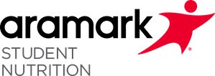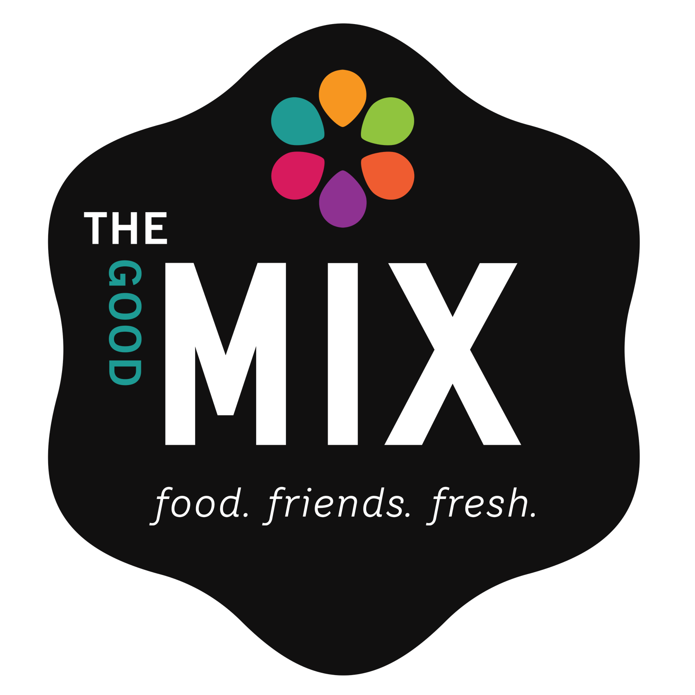

**Week of 6/05 – 6/16**

Blueberry Yogurt Parfait

**Week of 6/05-6/09**

Apple Orange Yogurt Smoothie

**Week of 6/05 – 6/09**

Orange and Yogurt Parfait

**Week of 6/05-6/16**

Chocolate Dipped Strawberry Smoothie

**Available Tuesday & Thursday!**

**Smoothies**

Oatmeal Bar

Strawberries

Cinnamon

Syrup

**Available Daily Options May Include:**

Blueberries

Mixed Berries

**Available Wednesday & Friday!**

Menu items are subject to change based on product availability.

**More info…**

**Fresh Fruit such as apples, bananas, oranges, pears & Assorted 100% Fruit Juice Available Daily**

**Milk Choices Include:**

**1% White or Fat-Free Flavored**

**More info…**

**To make a meal, students must select 3 or 4 items. At least one item must be a ½ c fruit or 4 fl. oz. fruit juice.**

**All students in Scranton School District are eligible for universal free breakfast.**

Assorted Nutri-Grain Bars

Assorted PopTarts

Bagel (w/ or w/o cream cheese)

Fruit Frudel

Filled Crescent Rolls

Mini Pancakes/Waffles

Granola and Graham Crackers

Yogurt and/or Cheese Stick

**Available Daily Options May Include:**

Assorted Cereals

Assorted Cereal Bars

Assorted Muffins

**Breakfast Cart**

**Parfaits**

**Available Tuesday & Thursday!**

**Assorted HOT & DELICIOUS Breakfast Sandwiches Available Daily!**

**Egg & Cheese Bagel**

**Bacon, Egg, & Cheese Bagel**

**Sausage, Egg, & Cheese Bagel**

**Sandwiches**

This institution is an equal opportunity provider.

**High School Breakfast Menu**

**June 2023**