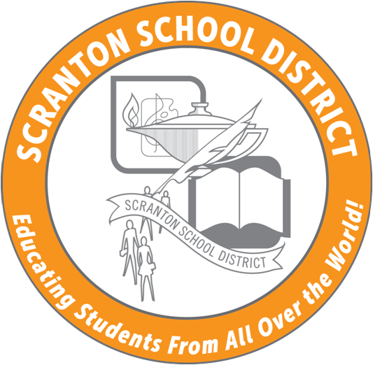

425 North Washington Avenue
Scranton, Pennsylvania 18503

SCRANTON SCHOOL DISTRICT
Educating Students From All Over The World

SAFETY COMMITTEE MEETING
ZOOM SESSION
Tuesday, May 26, 2020
2 PM-3 PM
AGENDA
- Welcome
- Minutes (February)
- SSD Safety training annual webinar-cancelled for 2020
- Building inspections-Cancelled for 2020
- Health & Safety re-entry
  - Central Administration along with school nurses ready to discuss plans within CDC PA DOH guidelines (see handouts).
- Google Form Today's attendance
- June invite/link
- New Business
- Next Meeting June 23, 2020-10 AM
  - Invite has been sent including NEIU link for ACT 48 credit-1 hour
  - Tentative 2020 SUMMER monthly meeting dates-10 AM start-ZOOM SESSION
    - July 28, 2020
    - August 18, 2020

